Meeting Minutes from 16/07/2012

Participants: Lei Li, Timo Pukinkorva, Mark Freed

**Overview**

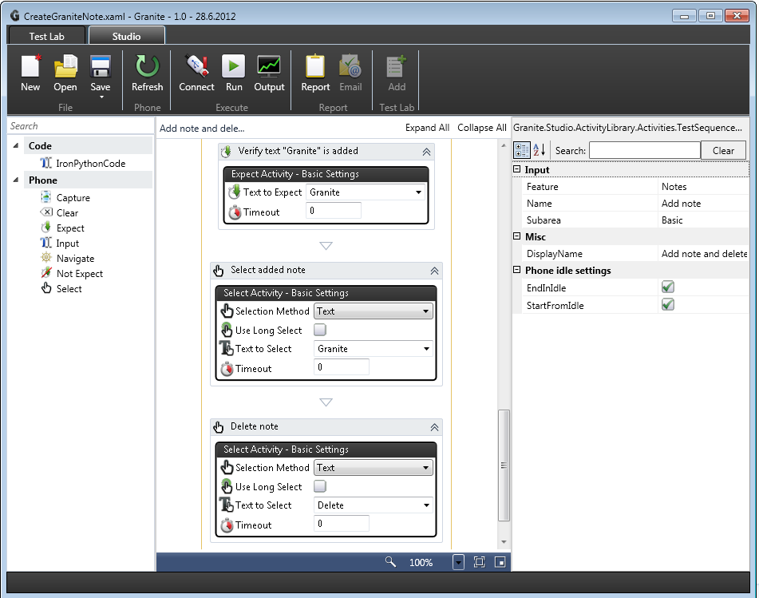

Figure 1 Existing Granite Studio UI and workflow activities

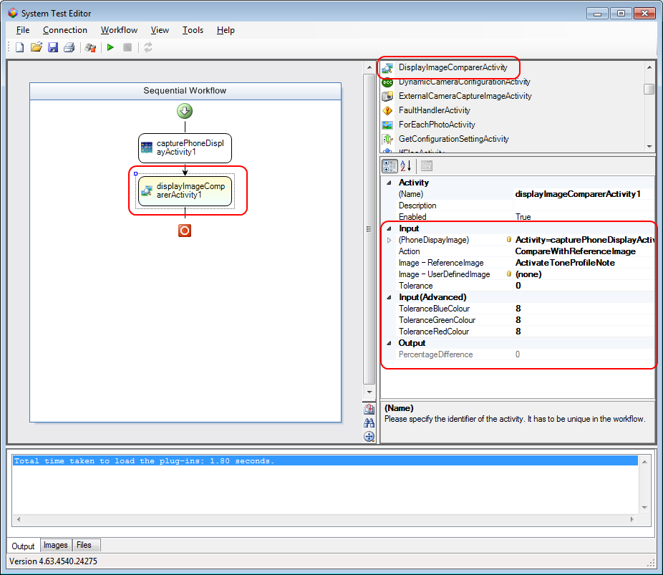

Figure 2 STE with DisplayImageComparerActivity

Currently in STE users maintain the reference images and masks through web pages (hosting browser control in STE):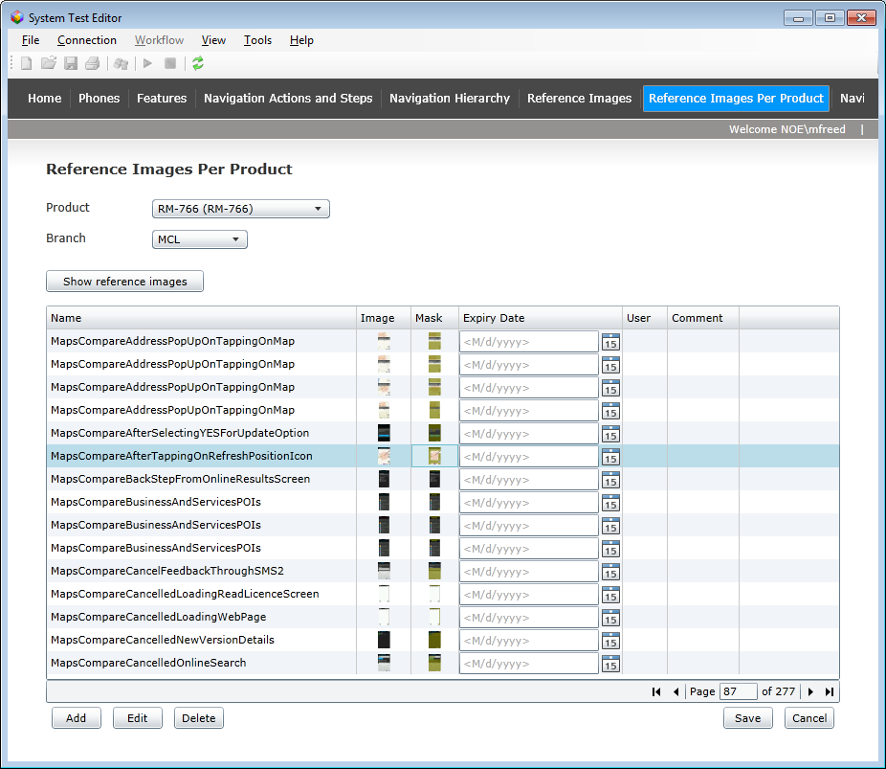

Figure 3 STE with web pages to maintain reference images

STE users can also access the web pages to maintain reference images directly from Internet Explorer: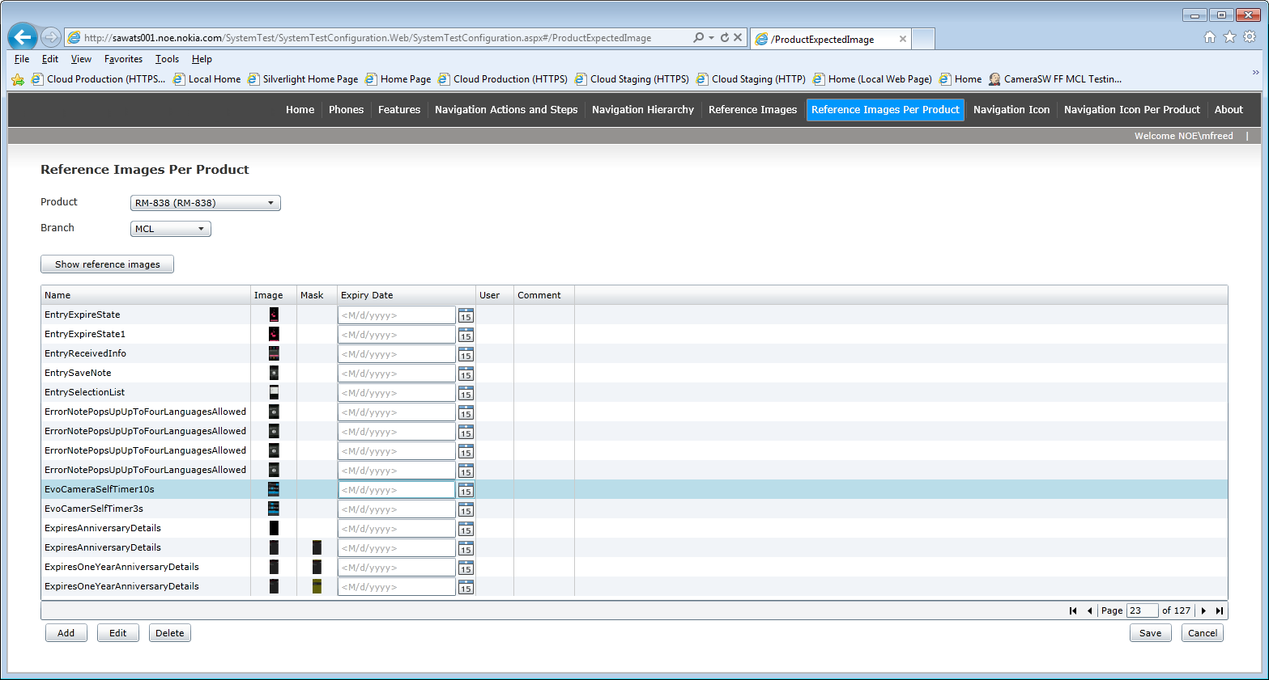

From Granite we need functionality to allow users to add local reference images and masks, similar to the following functionality provided by the STE web pages:

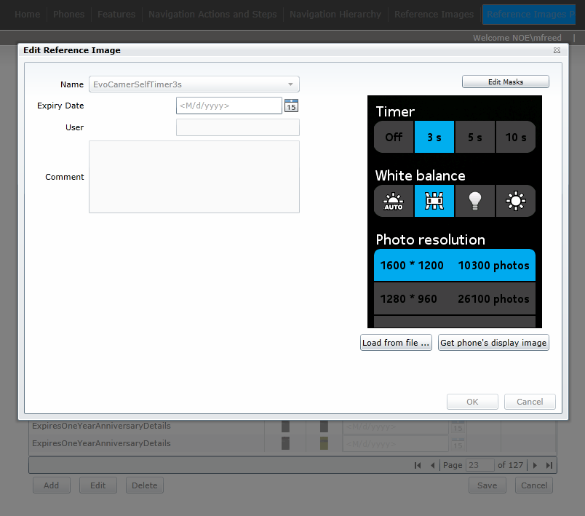

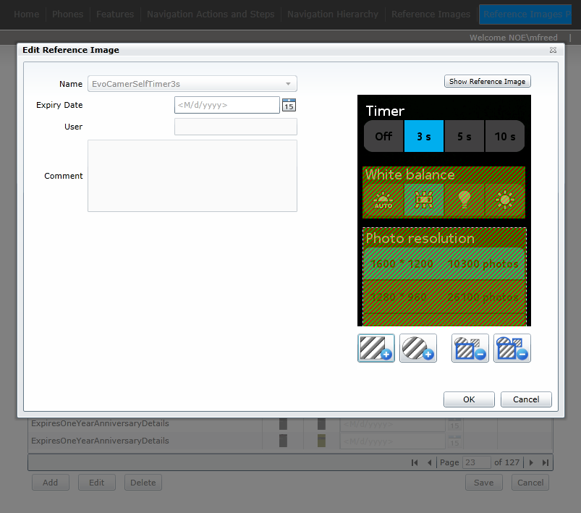

**Conclusion in Meeting**

Requirements is to only port the DisplayImageComparerActivity STE code that compares locally stored images, NOT any of the cloud and database functionality.

18/07/2012:   
Mark Freed: Having looked at the solution in Granite where we use locally stored reference image files, I am concerned that the display image comparison implementation in Granite will not be as sophisticated as that provided by STE. For instance there will not be support for the following:

1. Multiple reference images where a phone display image changes over time and we can easily store reference images for all the variations.
2. The ability to have the workflow XAML tests work on any products, since with local reference image files it will be extremely difficult to maintain all phone reference images per product, or ensure that the XAML test files are distributed with the correct set of phone reference images.
3. Ability to run workflow XAML tests located in any directory or from any site (since users will need to remember to copy across all associated phone display reference images).
4. Easily store and maintain additional information with reference images, such as expiry dates for certain reference images.
5. Allow users to very easily maintain and update all of the reference images, since the workflow activity will be linked to a single reference image file, therefore will be maintained per test case.
6. Mechanism where users can easily click a button when reviewing display image reference comparison results to update/upload a new reference image (such as is provided from the System Test Image Viewer).

We can however provide a very simple implementation, where phone display comparison is done with a single masked reference image file.

Wekey to create and add the DisplayImageComparerActivity into Studio, but UI work to be done by Juhani. Juhani to do the UI work for adding image masks.

Work as a single team with Mark co-ordinating Studio work with Wekey.

Action: Jani to provide Wekey with access to Granite UI GIT repository on \\oucifs1\fp_ts_fi\work\

18/07/2012: Only Timo has access rights to be able to do this. Timo will give Wekey access rights when he next comes by the office, but in the meantime we will need to transfer source files back and forth. Mark to co-ordinate this with Wekey.

Action: Mark to co-ordinate meeting with Jani & Wekey to cover the display image comparison work.  
DONE 18/07/2012  
Jani has produced an initial list of requirements and Mark has produced a document providing further technical detail about the requirements which will be covered in the meeting on 19/07/2012.

**Other topics:**

**Meeting to managers to show there is no overlap**

**No overlap** of Granite with STE/STA

Action: Mark to create presentation to explain this. To be reviewed by Lei Li and Wekey and Granite team (Jani).  
DONE 17/07/2012

Plan has been to port any “good” functionality from STE over to Granite.

**STE cloud architecture**

This is provided as background information only, since the cloud architecture is applicable to the DisplayImageComparerActivity functionality in STE. Note that the display image comparison functionality in Granite will not use the cloud.

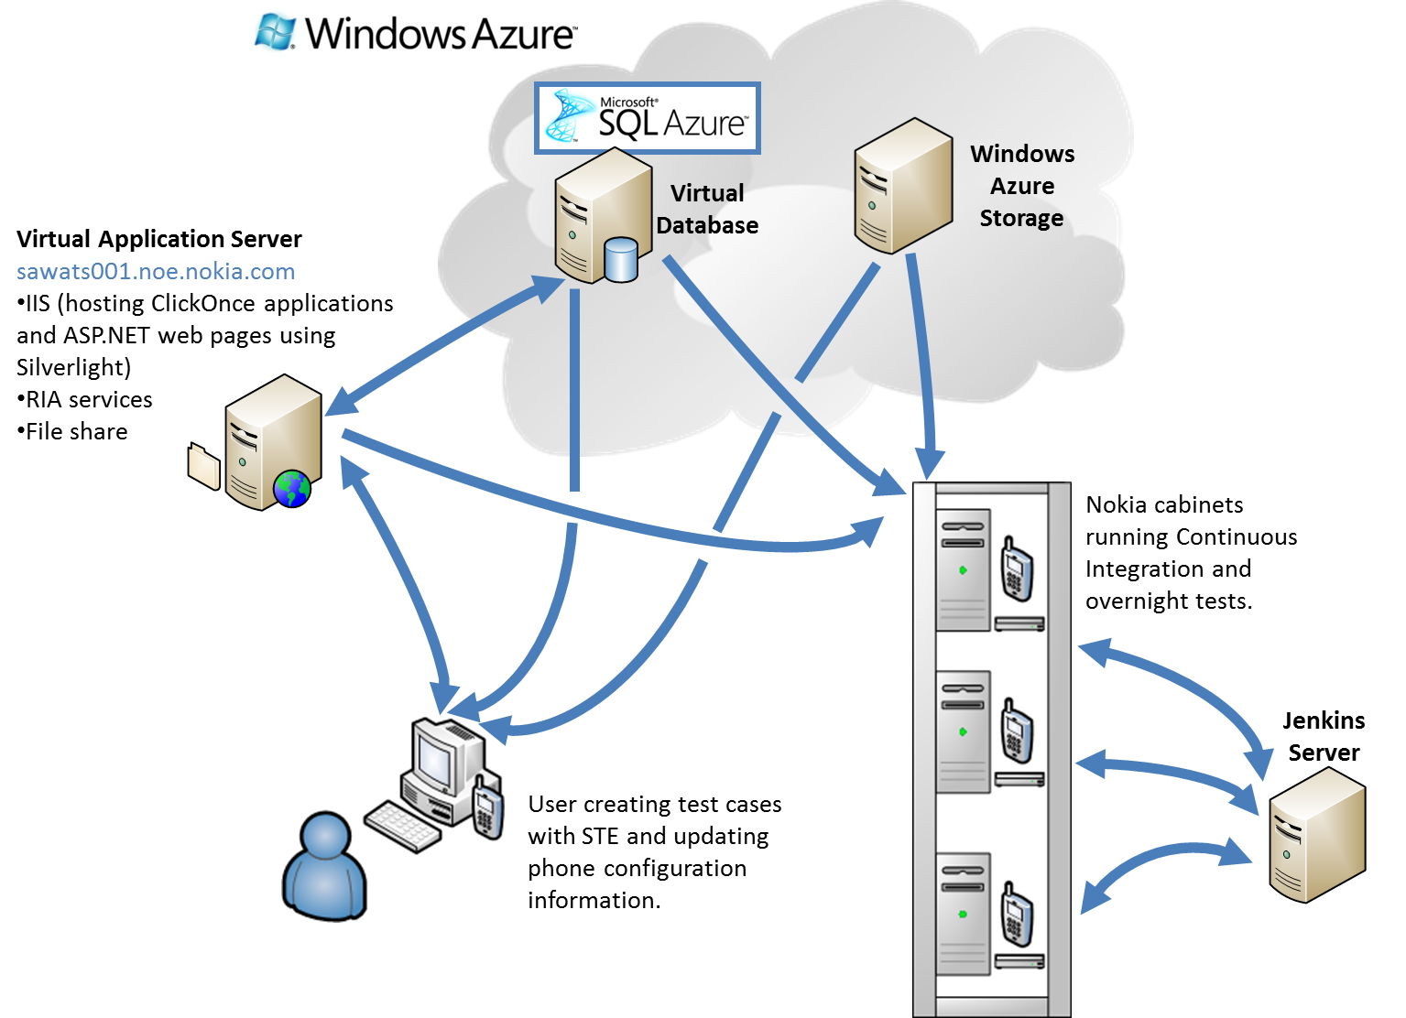

Figure 1 Overview of existing STE/STA architecture

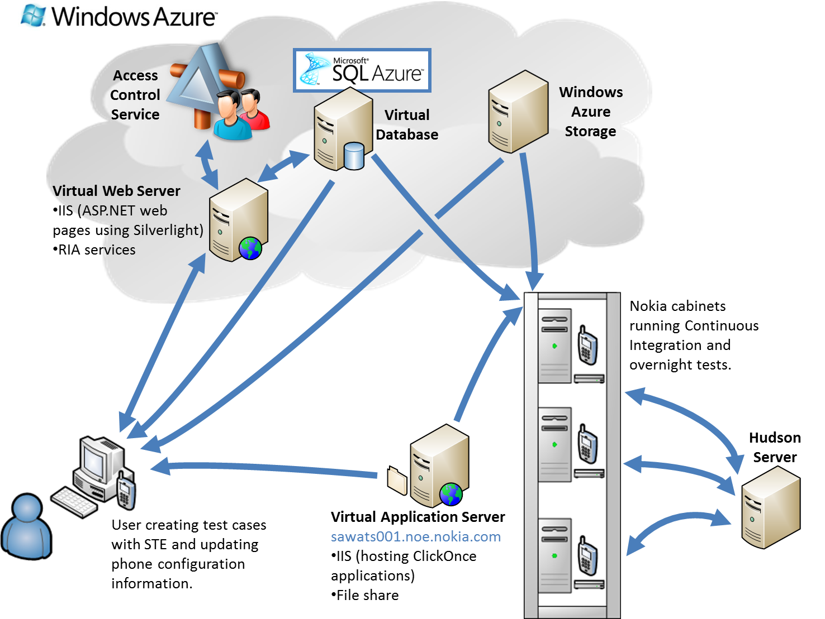

Figure 2 Overview of new architecture

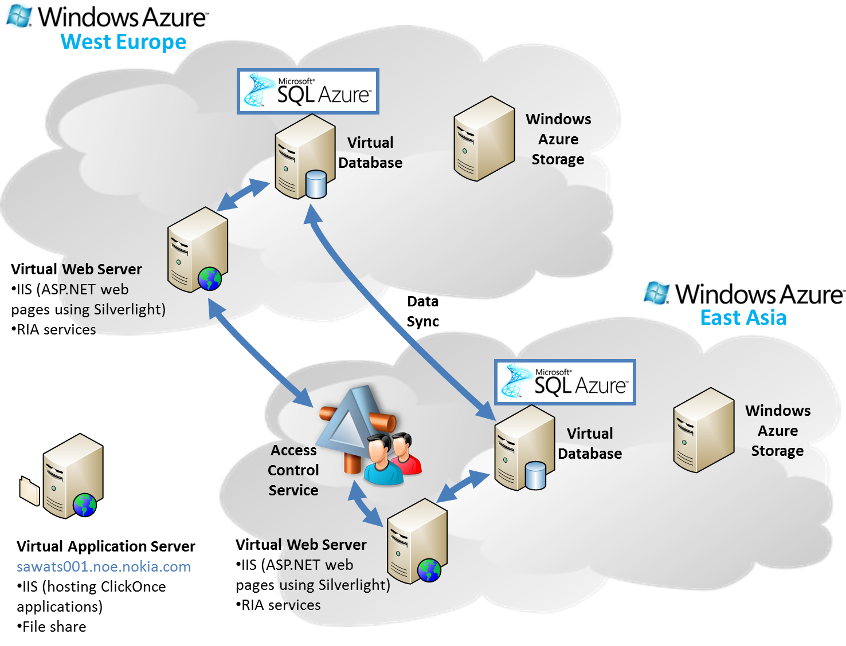

Figure 3 Data Sync between West Europe and East Asia